

Minecraft XBLA Design Changes/Additions

Author – Paddy Burns
Version 1.1 – 30^{h} November 2011

TABLE OF CONTENTS

Overview 1
Font 2
Front End (Menu) Changes 3
Main menu 3
Tutorial/Load/Join/Create game menu 4
Pause Menu 5
Controller Layout 6
User Interface 7
Saving 7
Example HUD with layout detail 7
Multiplayer 8
Multiplayer Split-screen HUD 8
Four local players split-screen 8
Four local players split-screen with layout details 9
Two player horizontal split-screen 9
Two player vertical split-screen 10
Achievements & Other Awards 11
Other Awards 13
Leaderboards 14
1. Travelling Leaderboard 14
2. Mining Blocks Leaderboard 14
3. Mining Ore Leaderboard 14
4. Farming Leaderboard 15
5. Kills Leaderboard 15
6. Nether Leaderboard 15
Tooltips 16
Trial Version 17
Tutorial 18
Rich Presence 19
Crafting Screens 20
Crafting menu controls and layout 20
Inventory Crafting screen (2x2) 20
Crafting Table screen (3x3) 21
Inventory/Containers Screens 22
Inventory screen 22
Small Chest 23
Large Chest 23
Furnace 24
Dispenser 24
Debug/Cheats Functionality 25
Downloadable Content 26

Change Table

Change | Who | Date
Added 4 last achievement icons | PB | 26/10/11
Added detail that only the host of a multiplayer game can save the level | PB | 30/11/11
Updated screenshots | PB | 30/11/11
Re-arranged Leaderboards so kills was later in the list | PB | 30/11/11
Added a Trial Version description | PB | 30/11/11
Added to the multiplayer description for splitscreen players joining/leaving | PB | 30/11/11
Added a Debug/Cheats section | PB | 16/01/12
Updated the Trial description | PB | 16/01/12
Updated the Leaderboard definitions | PB | 16/01/12
Extended the tooltips section to add the in-game tooltips | PB | 16/01/12
Added to the Overview to show multiplayer details | PB | 16/01/12
Added a Downloadable Content section | PB | 16/01/12
Updated screen captures in the document | PB | 16/01/12
Changed MOAR Tools achievement to 4 tools – it was confusing as to what was required to achieve it. | PB | 21/02/12
Updated the splitscreen section to HD modes only | PB | 01/03/12
Removed 2 leaderboards since we can’t write to more than 5 at a time | PB | 02/03/12
Change On A Rail achievement to 500m | PB | 12/03/12
Updated Rich Presence | PB | 12/03/12
Updated Rich Presence | PB | 14/03/12

Overview

This document describes the changes and additions made to the Minecraft Java game for the Xbox 360 console.

All screen graphics & fonts in this document are placeholder/prototypes!

The main changes made to the functionality of the game are:-

- A new auto-build crafting interface allowing for easy navigation using the Xbox controller
- A set world size, with edges blending into water, to work within the memory limitations of the Xbox.
- Split-screen functionality allowing four players on the one Xbox.
- Tutorial on how to play Minecraft added
- Hints system to show the player what items & blocks are, and what can be done with them.
- Peer to Peer network games of up to eight players.
- Social Network sharing of in-game screenshots.

Multiplayer/Online details

There is no single player game as such – the game is always in multiplayer mode, although can be set to offline game.
There can be up to four players in split-screen on a single console, and up to eight players in a Live online game.
Due to the likelihood of ‘griefing’ (where a player destroys what another player has built) , the only online game type is Friends, and the player can join a Friends game in progress.
Host migration is not supported.
The game uses the Microsoft provided QNET.

Save system details

The title uses manual saves via the Pause menu, and auto-saves on the player leaving the game level to a save file.

Settings save details

Settings are saved to the player’s profile (Controls selection, Invert Look, Southpaw, Music and Sound Effects volumes, Gamma setting, View bobbing, 2 player split-screen setting, and game difficulty mode).

Font

To preserve the look of Minecraft, we will be using a pixelated looking font with the same kind of style as the current bitmap font, although for the Japanese/Chinese/Korean languages, we expect we will have to move to a less stylised font.

Front End (Menu) Changes

The front end code will be re-written entirely.

Main menu

Technical Certification Requirements for this menu are:-
Xbox LIVE Arcade titles must support a main menu that includes the following menu options:

Leaderboards
Achievements
Help & Options
Unlock Full Game (trial version only)
Download Content (full version only, if applicable)
Exit Game

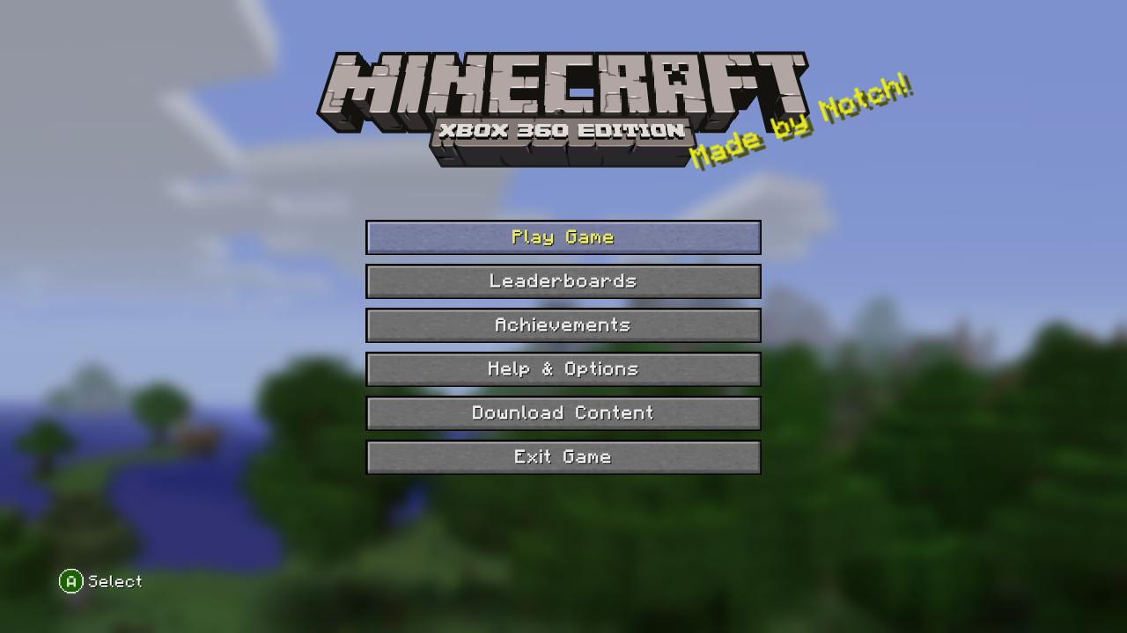

Tutorial/Load/Join/Create game menu

In addition to the save game name, we propose a thumbnail screenshot of the world display to be displayed with each save game.

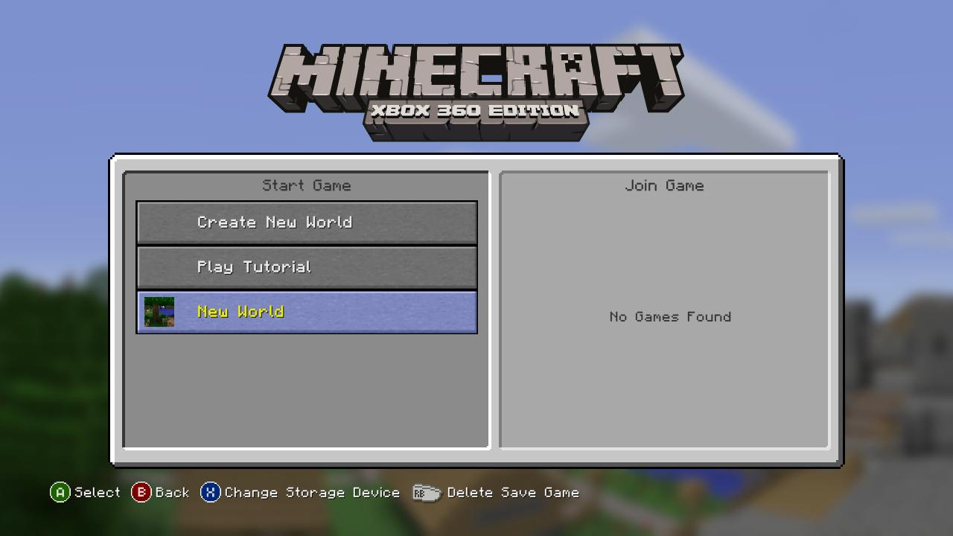

Pause Menu
Technical Certification Requirements for this menu are:-
Xbox LIVE Arcade titles must support a pause menu that includes the following menu options:

• Resume Game
• Help & Options
• Leaderboards
• Achievements
• Save Game (if applicable)
• Exit Game

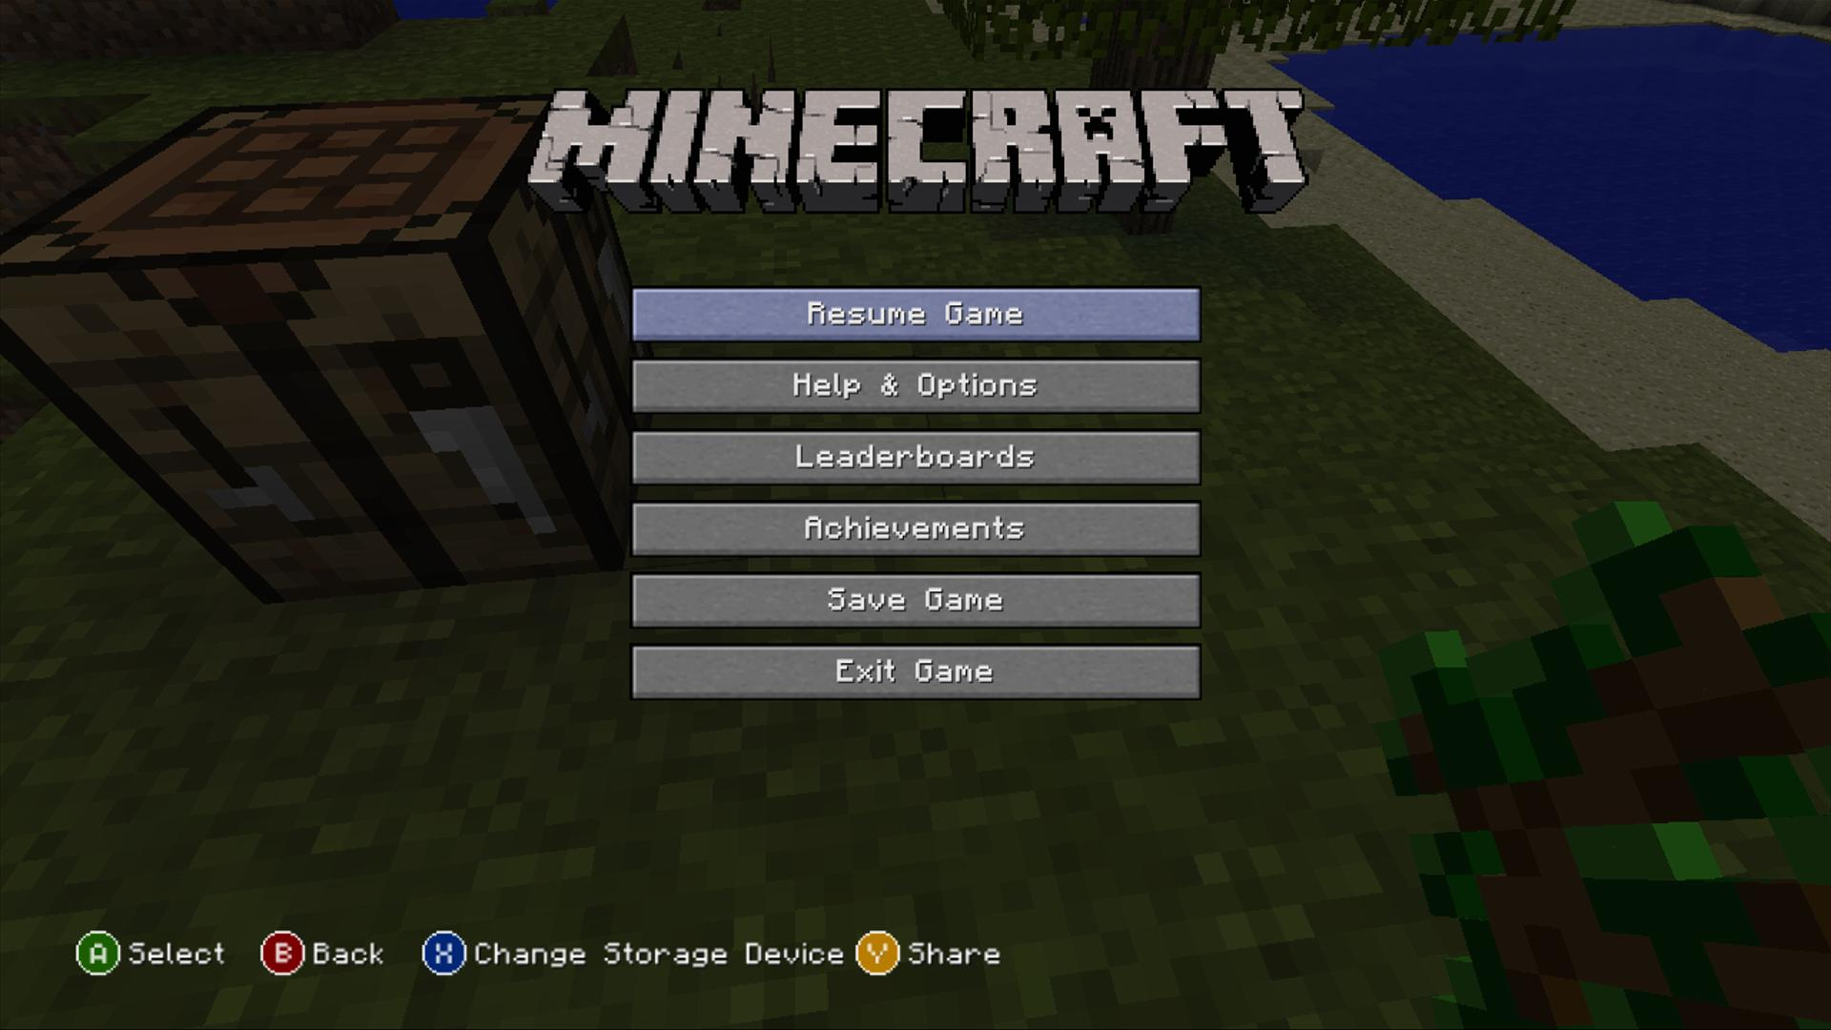

Controller Layout

There will be three alternate controller layouts for the user to choose from. Layout 1 is the intial controller layout. Controls may be changed during playtesting.

We can also give the user some options within these controls to alter them, and we will read the Xbox user preferences to apply to the default control layout (swapping sticks, etc.) on the first launch of the game.

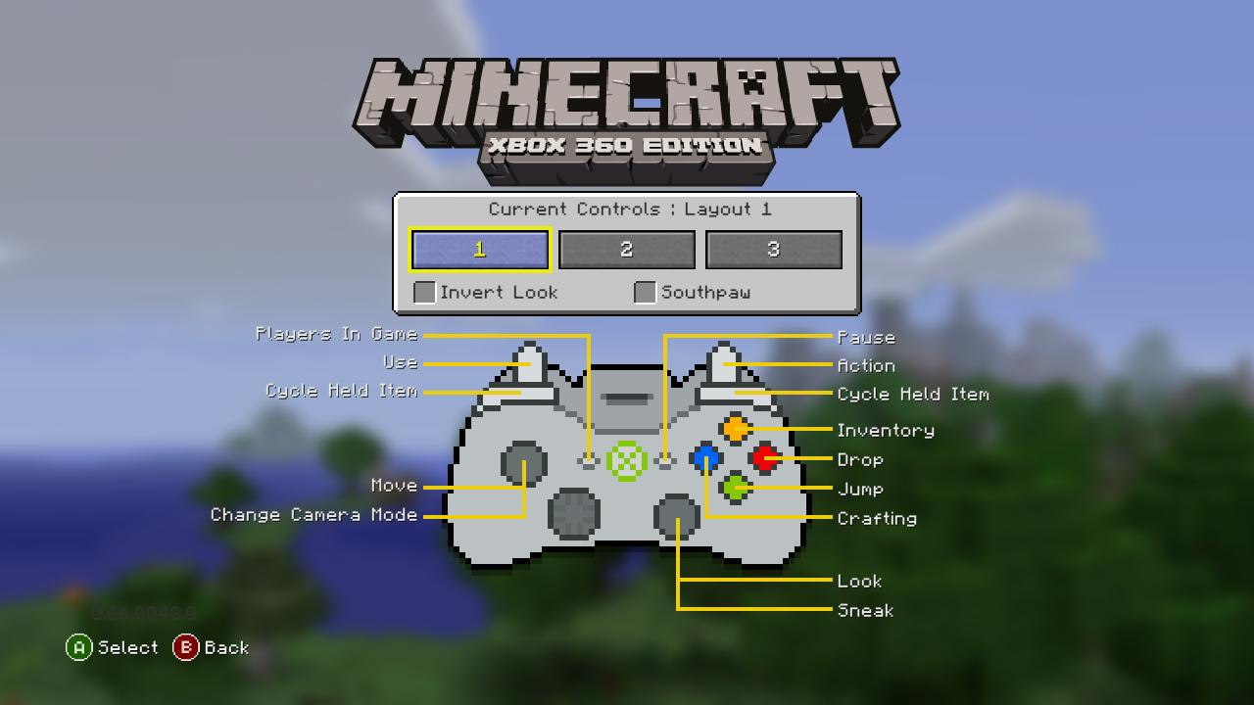

User Interface

The HUD will follow the layout on the Java game, with re-positioning where necessary due to specific Xbox 360 requirements. The HUD will be within the TCR required 90% safe area. Also shown are the Xbox System messages for general UI popup, and a saving message.

Saving
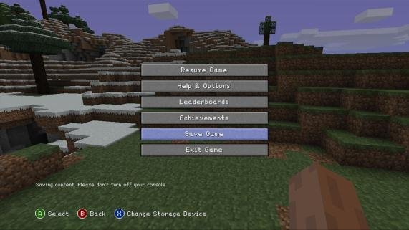

Example HUD with layout detail
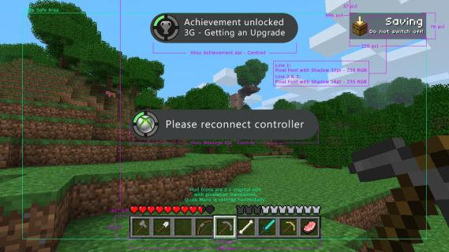

Multiplayer

We will implement the multiplayer mode to allow for games between up to 8 friends, with any combination of up to 4 local players per console. The host of a game could be any one of the local players, and will be positioned on screen by their joypad quadrant. Players will be able to drop out and in of a game in progress, and we aim to have host migration if possible when the host drops out of the game.
Only the host will be able to save the level, since they will be running the server which will have all the required information for that level. Local players will join the game by pressing a button on their controller, and then pressing the Start button as prompted on screen. When a local player leaves the game (by signing out or choosing Exit from the Pause Menu), the screen-split will be re-organised as needed.
We will need to store a list of players inventories, dimension, sleep time, spawn position, health, on fire, etc. in the save game. We will need to limit the slots for this data, so it will be possible that a player could re-join a multiplayer game, and not have the inventory items they expected. We will also need to use the player’s XUID along with this data, so that they can be identified as owning the data when they re-join.
Multiplayer splitscreen will only be available in HD modes, and the first tip in the game on the loading of a save will inform the player that they could play in splitscreen if they were in an HD mode.

Multiplayer Split-screen HUD

Four local players split-screen (HD modes only)
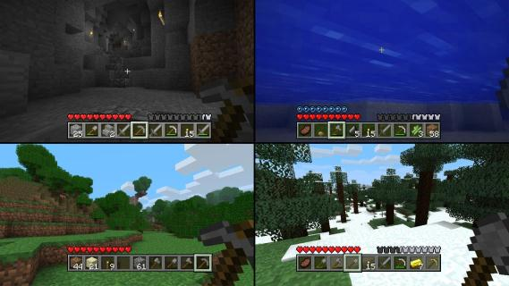

Four local players split-screen with layout details (HD modes only)
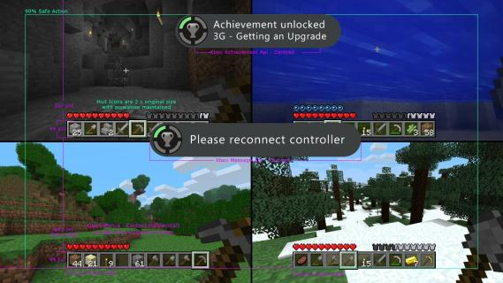

Two player horizontal split-screen (HD modes only)

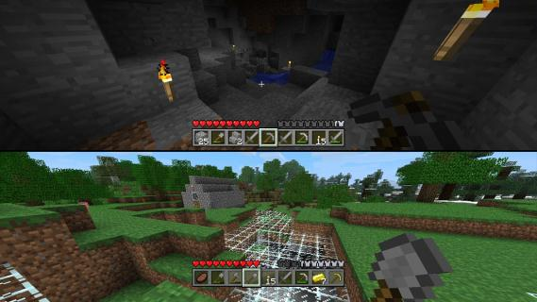

Two player vertical split-screen (HD modes only)

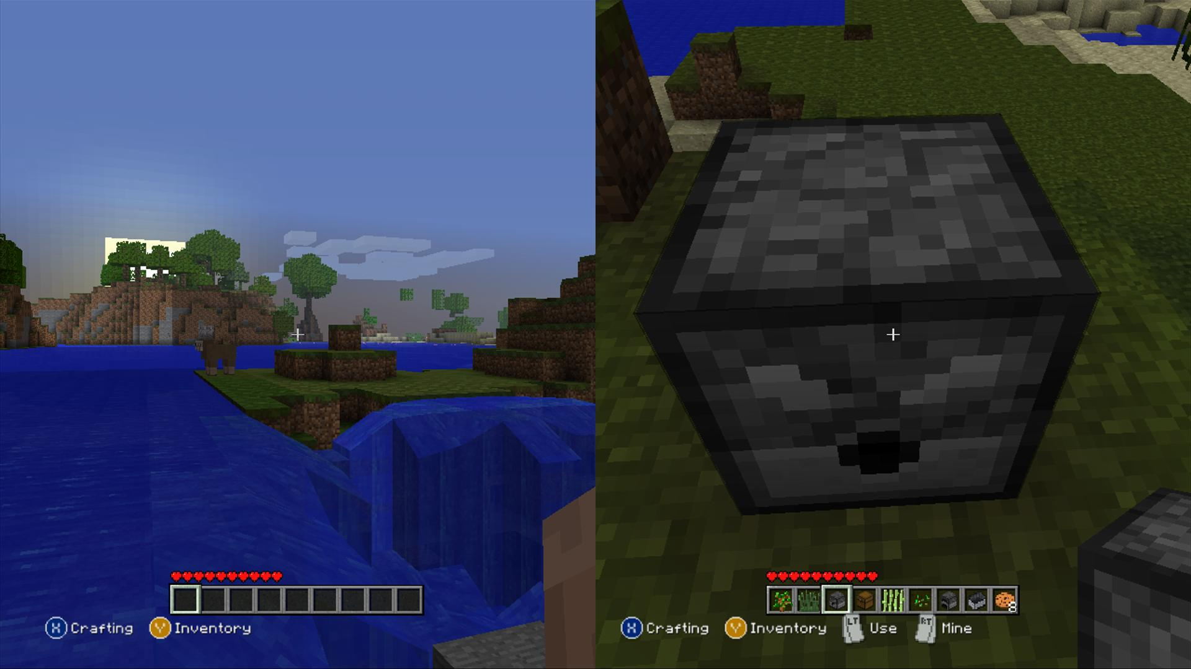

We will require TCR waivers for the standard XBLA pause menu when in split-screen mode, since some of the required items (e.g. Leaderboards) will not be readable.

Achievements & Other Awards

We’ll be using the existing 16 achievements from the Java game, and will be adding the following in-game awards:-

- Four new achievements (to bring the total to twenty)
- A Theme award
- Three avatar awards
- Two gamerpics

 | Icon | Name | Descriptions | Score
1 |  | Taking Inventory | Open your inventory. | 10
2 | 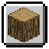 | Getting Wood | Punch a tree until a block of wood pops out. | 10
3 | 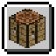 | Benchmarking | Craft a workbench with four blocks of wooden planks. | 10
4 | 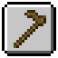 | Time to Farm! | Make a Hoe | 10
5 | 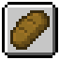 | Bake Bread | Turn wheat into bread. | 20
6 |  | The Lie | Bake a cake using: wheat, sugar, milk and eggs. | 40
7 |  | Time to Strike! | Use planks and sticks to make a sword. | 10
8 |  | Monster Hunter | Attack and destroy a monster. | 20
9 |  | Cow Tipper | Harvest some leather. | 15
10 |  | When Pigs Fly | Use a saddle to ride a pig, and then have the pig get hurt from fall damage while riding it. | 40
11 | 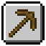 | Time to Mine! | Use planks and sticks to make a pickaxe. | 10
12 | 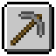 | Getting an Upgrade | Construct a better pickaxe. | 15
13 | 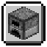 | Hot Topic | Construct a furnace out of eight cobblestone blocks. | 15
14 | 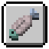 | Delicious Fish | Catch and cook fish! | 15
15 | 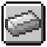 | Acquire Hardware | Smelt an iron ingot. | 15
16 |  | On A Rail | Travel by minecart to a point at least 500m in a single direction from where you started. | 40
17 |  | Leader of the Pack | Befriend five wolves | 30
18 | 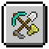 | MOAR Tools | Construct one type of each tool (pickaxe, shovel, axe & hoe) | 15
19 | 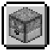 | Dispense With This | Construct a Dispenser | 20
20 |  | In to the Nether | Construct a Nether Portal | 40

Other Awards

 | Icon | Description
Theme |  | Make a social network post from the Xbox game.
Avatar 1 |  | Pork Chop T-Shirt – Eat a cooked pork chop.
Avatar 2 |  | Minecraft Watch – play for 100 game days.
Avatar 3 |  | Creeper Cap – Kill a Creeper with arrows.
Gamerpic 1 |  | Dig 100 blocks.
Gamerpic 2 |  | Kill 10 Creepers.

Leaderboards
The stats display in the Java game will be replaced using Xbox LIVE Leaderboards. There will be one set of Leaderboards per difficulty setting. There are four difficulty levels – peaceful, easy, difficult, and hard.
Wherever possible, icons will be used in the Leaderboards rather than text.
Upper limits will be placed on the counts to avoid overflow.
Rank will need to be able to display tens of millions.

Every leaderboard will display the Rank, and a Gamertag for each entry, and will have a title bar showing column headings for all information in the leaderboard. Wherever possible, icons will be used in the title bar. Values will be posted when a distance travelled changes, or an item is collected/built, or an enemy is killed.

Travelling Leaderboard

This Leaderboard will display the distances travelled by walking, falling, in a minecart, and in a boat. The players are ranked by the combined values of all the distances, with the highest combined total being ranked at 1.

Walked | Fallen | Minecart | Boat
 | 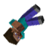 |  | 

Mining Blocks Leaderboard
This leaderboard will display the number of blocks of each type below that the player has mined. Players will be ranked by the total number of items mined, with the highest value ranked as number 1.

Dirt | Stone | Sand | Cobblestone | Gravel | Clay | Obsidian
 |  |  |  |  |  | 

Farming Leaderboard
This leaderboard will display the number of items of each type below that the player has mined, collected, or milked. Players will be ranked by the total number of items, with the highest value ranked as number 1.

Eggs Collected | Wheat collected | Mushrooms collected | Sugar Cane collected | Cows milked | Pumpkins collected
 |  |  |  |  | 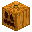

Kills Leaderboard
This leaderboard will display the number of kills of each type of enemy. Players will be ranked by the total number of kills, with the highest value ranked as number 1. This leaderboard will not be present for the Peaceful difficulty.

Zombies | Skeletons | Creepers | Spiders | Spider Jockeys | Zombie Pigmen | Slime
 | 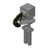 | 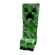 | 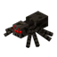 | 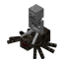 | 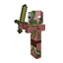 | 

Tooltips

Tooltips are a standard within Xbox Live Arcade games, and appear along the bottom of the screen showing what button presses are available on the current menu, and what the press will do.
We will add these to all menu screens, and crafting/container type screens.
We will also add tooltips for in-game actions, and this will allow the player to see what they sctions they have in the game, depending on the combination of items they have in their hands, and items/blocks the cursor is over.

Trial Version

The aim of the Trial Version of the game is to give players a taste of Minecraft, and to get them wanting to unlock the full version to continue with the game. In order to do this, we will need to mix some basic training with a lot of pre-built areas showing off the features they would be able to build after playing the game for a while. The player will be limited to twenty minutes of play in the trial version, and will need to unlock the full version to continue beyond this.
The player will have access to all functionality available in the full version (no locked features), barring saving and awards (theme, avatar items, gamerpics and achievements). The player will receive an upsell when they trigger an award, and these awards will be given to them when they unlock the full game.
There will be an upsell displayed when the player hits the time limit in the trial.

Tutorial

The Tutorial Level will be used to introduce new players to the Minecraft world. We will introduce the key game actions, giving the player aims in order to complete their training. This Tutorial map will be the only one available to players in the Trial version (which will have a time limit on playing, and no saving), and will be a menu option in the Full version. In the case of a player downloading the Full game without playing the Trial game, we will ask on first launch if the player would like to enter the Training Level.

The Training Level will be a small world with a partially built shelter with a bed in it, and will cover the basics of:-

- Digging
- Building
- Crafting

The overall aims of the tutorial are:-

- Teach the player to build a crafting table
- Teach the player to craft a wooden pickaxe.
- Teach the player to complete the building of a shelter to be safe through the night.

Once the player has completed the tutorial to this point, they will be given the option of learning how to use some of the more complex items in the game, such as the furnace

We will use on-screen text and graphic prompts to remind/instruct the player about their next goal and how to achieve it.

Rich Presence

The rich presence strings are displayed when an Xbox Live user looks at the Friends menu. They show the game being played, and information about what the Friend is currently doing in the game.
Each of the possible 16 rich presence strings can consist of a maximum of two lines of text, and each line can have a maximum of 22 characters including contexts and properties.

For Minecraft, we propose the following example strings:-

Line 1 –

- “Playing Multiplayer”
- “Offline Multiplayer”
- “Playing Alone”
- “Offline Alone”

Line 2 -
- “Enjoying the view!”
- “Riding a pig”
- “Riding a minecart”
- “In a boat”
- “Fishing”
- “Crafting”
- “Forging”
- “In the Nether”
- “Listening to a disc” – green/gold disc
- “Looking at a map”

Crafting Screens

We will change the crafting menu to make it easier to navigate using a joypad, and we will replace the crafting system using a mouse and keyboard with an auto-craft system to make things easier to craft with the joypad. There will be a display of the ingredients required to craft the item, with missing ingredients highlighted in red. Items that cannot be crafted due to missing ingredients will be greyed out.
Each Craftable item will be assigned to a group, and also given a material and base object type to allow for vertical stacking of the same type of object using different materials.
The Group tabs will be displayed along the top of the menu
Tooltips will be displayed along the bottom of the screen showing the joypad button controls.

Crafting menu controls and layout

Game play Action | 360 Controls
Navigate Craftable Items | Left Stick or DPad Left/Right/Up/Down
Navigate Groups | RB/LB
Create Item | A
Toggle Description/Inventory Display | X

Inventory Crafting screen (2x2)

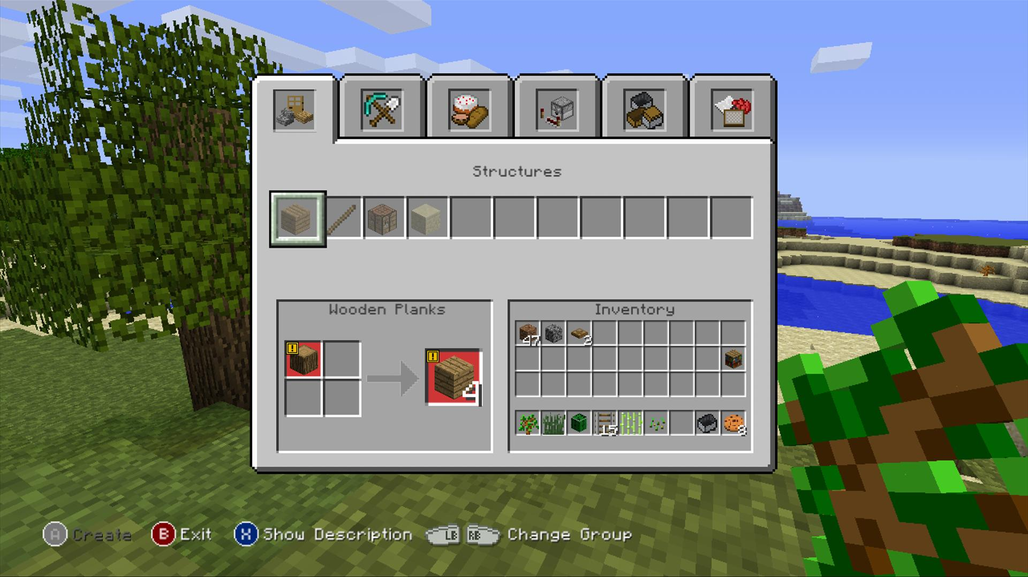

Crafting Table screen (3x3)

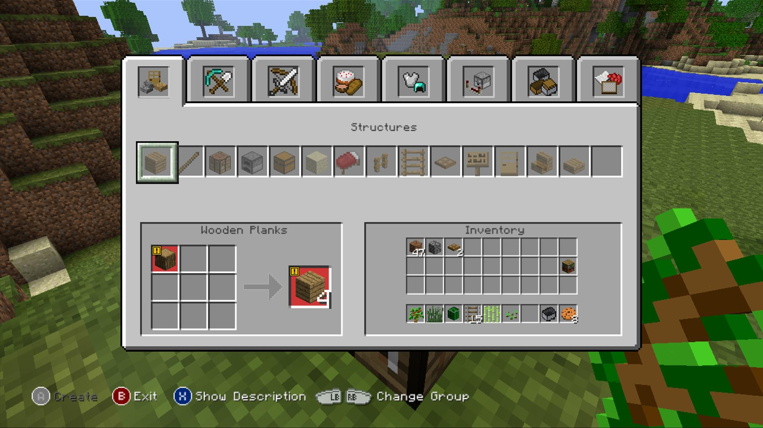

Inventory/Containers Screens
There are various container screen in the game, allowing items to be moved between the player’s inventory and the container. We will implement control where the joypad stick is used to move a pointer around the screen, with lock-on areas for the item boxes. This also allows us to implement the drop item control when the pointer is moved outside of the scene. In order for the pointer movement to be smooth, we will need to optimise the game code more than it currently is, but by testing turning off the game code in the background, the smooth pointer movement does feel good on this screen.

Game play Action | 360 Controls
Navigate | Left Stick
Pick Up All | A
Pick Up Half | X
Place All Items From Selection | A
Place Single Item From Selection | X
Drop All Selection | RB
Drop Single Item From Selection | LB
Quick move | Y

Inventory screen
The inventory screen will show the game character, armour, and inventory.

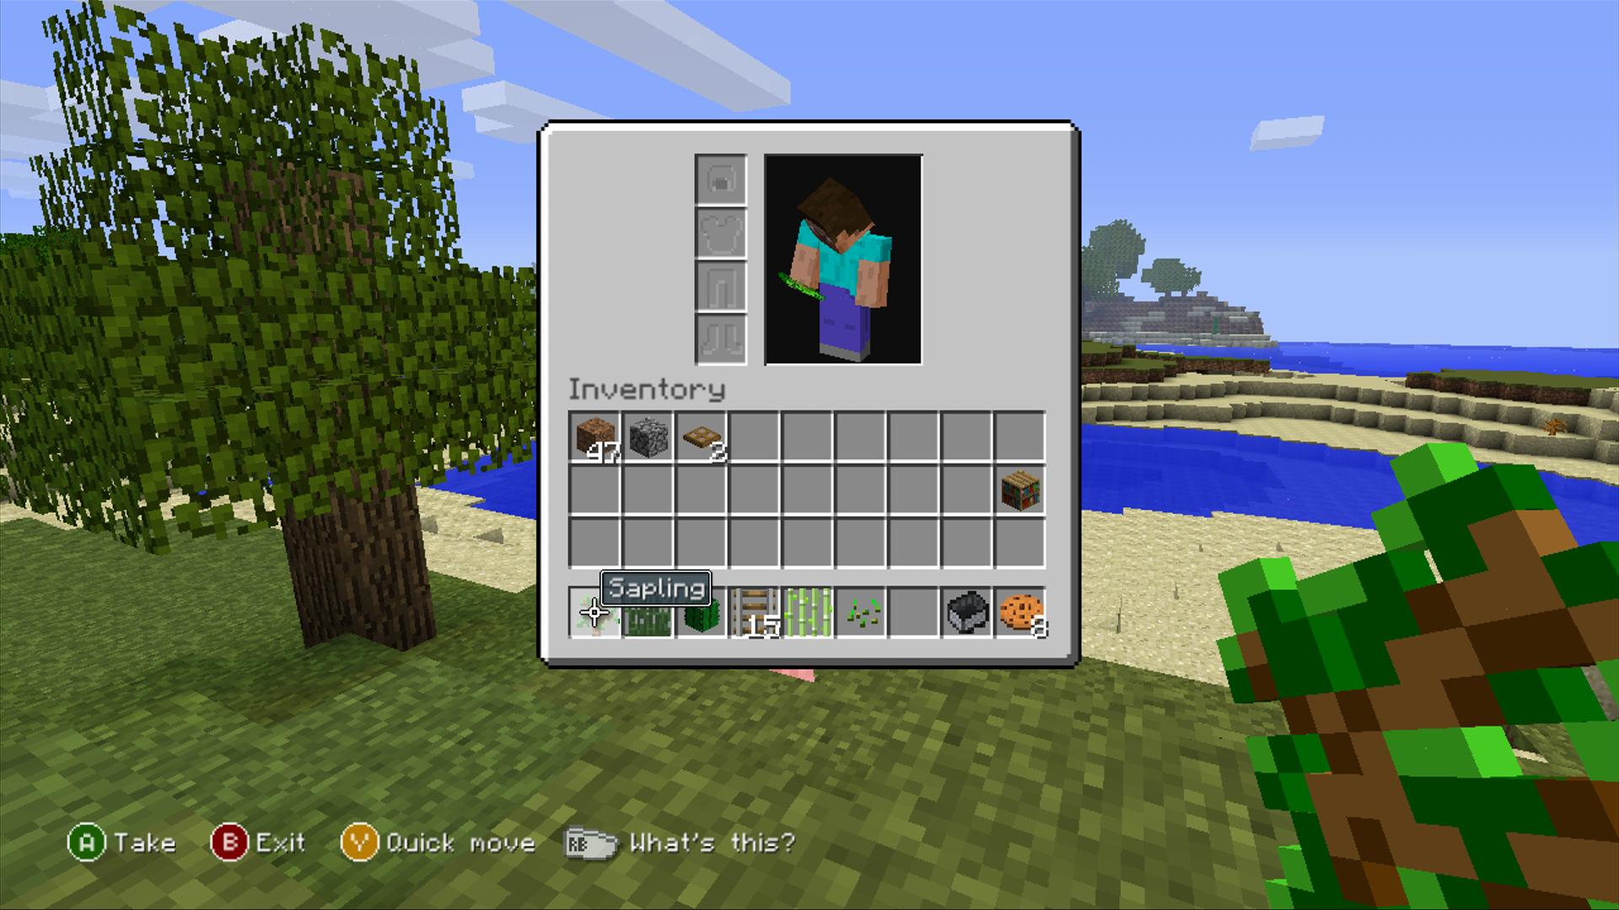

Small Chest
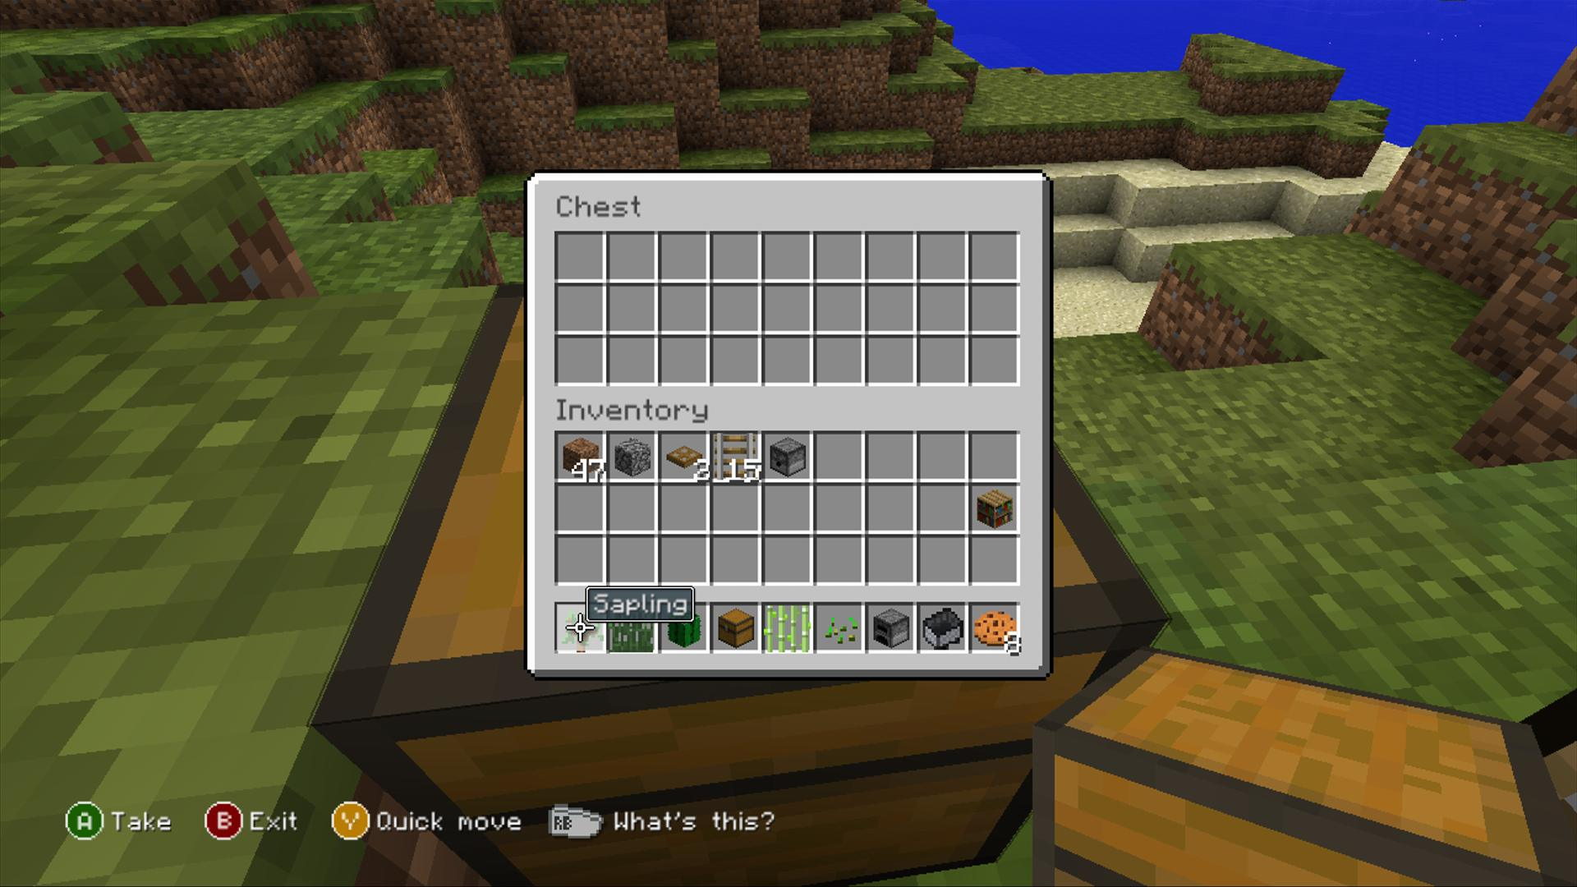

Large Chest
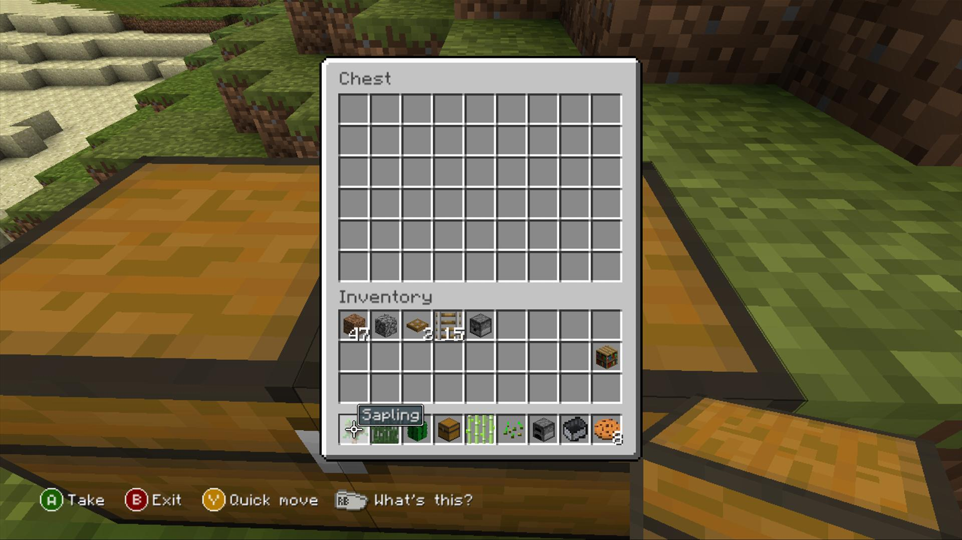

Furnace
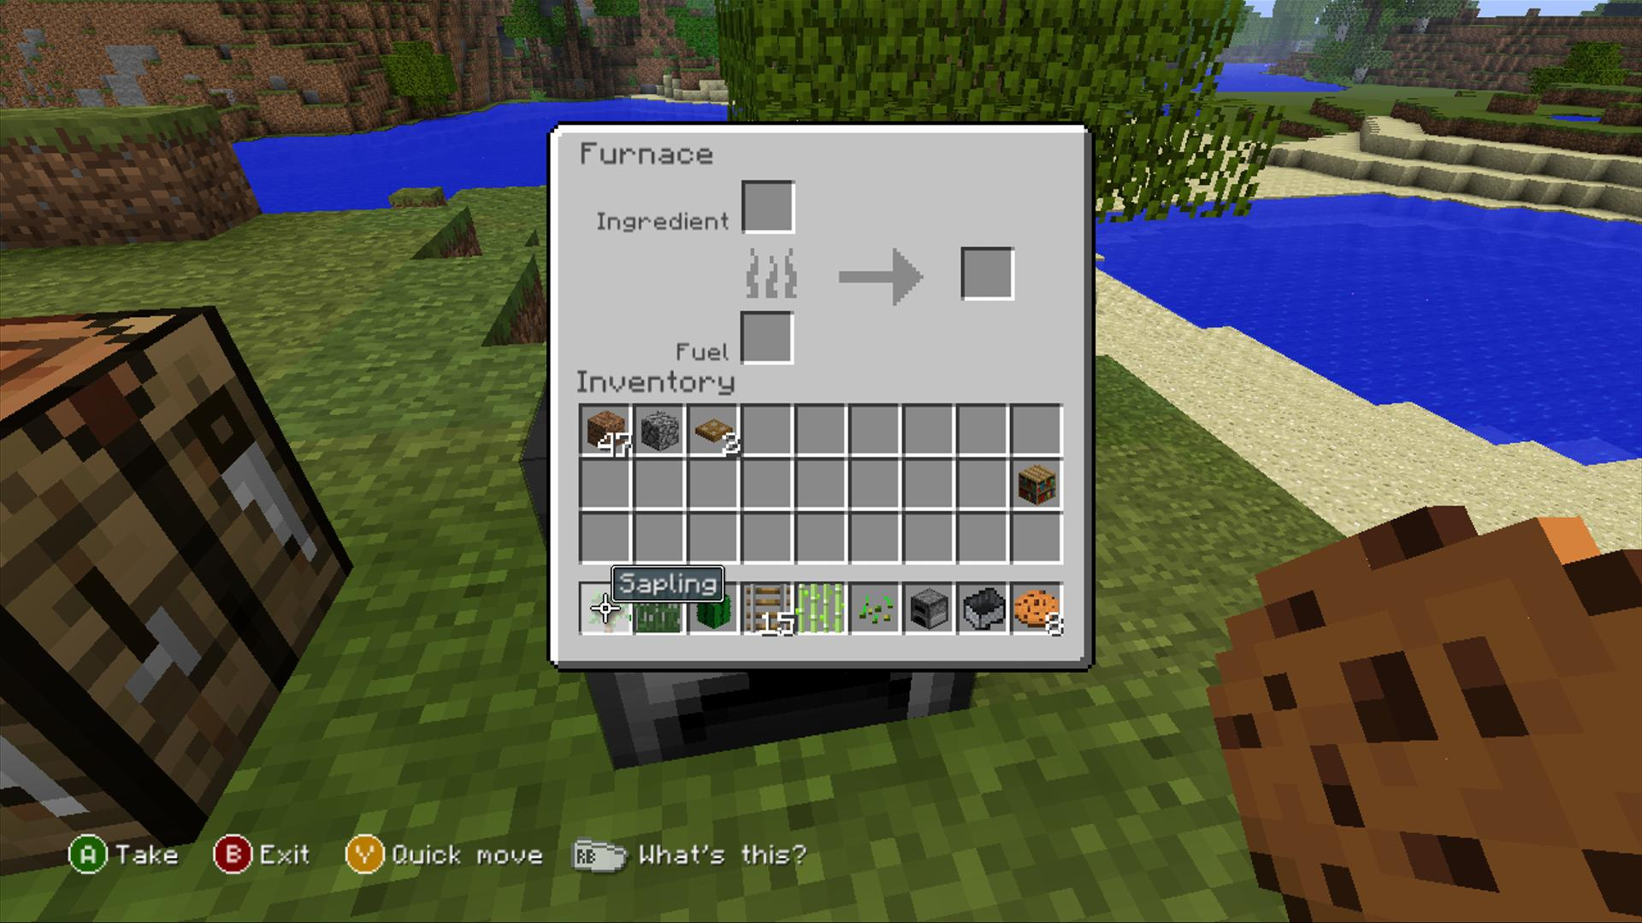

Dispenser
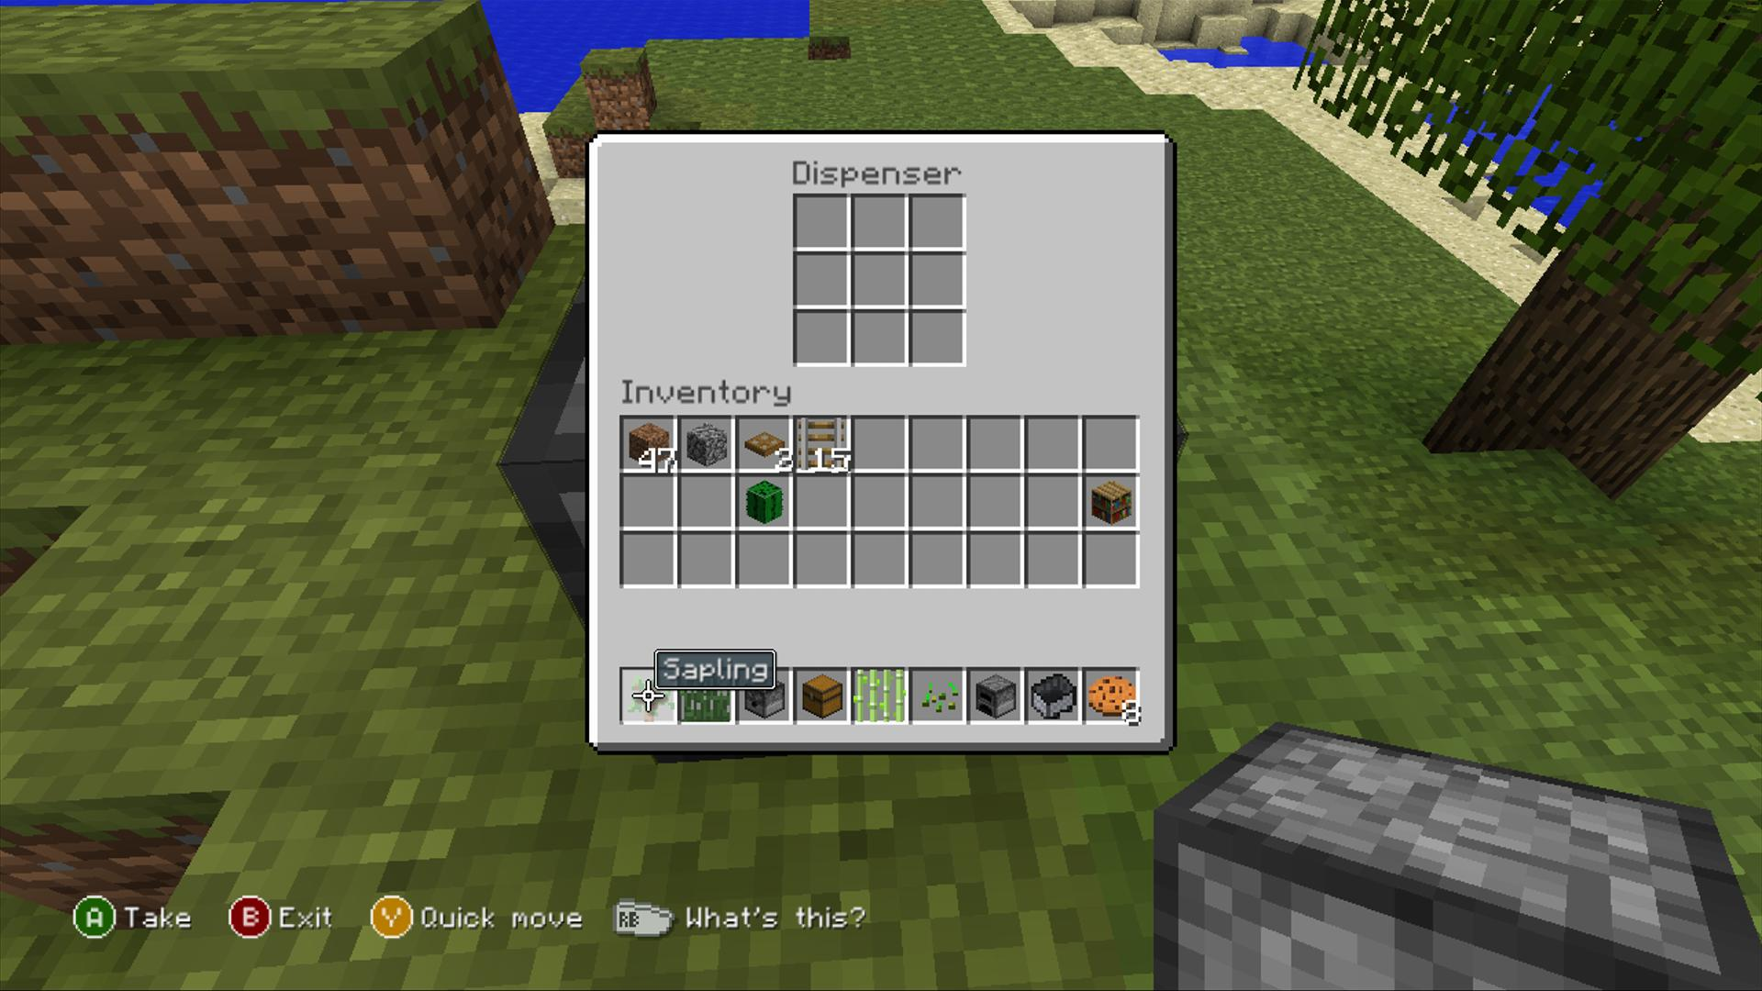

Debug/Cheats Functionality

We will have some debug functionality available in a Release/Debug build only (not Content Package build).
This includes a debug menu in-game, showing debug stats display, and allowing the user to select items to spawn into the world. This menu is accessed with dpad down.
In addition, there is a debug menu with toggleable options, accessed via the Help & Options/Settings/Debug Settings menu. These options include:-

Load Saves from local folder – When ticked, will display the devkit local folder save games (in the Saves folder on the devkit, one step down from the xex.

Write Saves to Local Folder Mode - When ticked, will save to the Saves folder on the devkit, as well as the usual save , one step down from the xex. The save will have a timestamped name to help identify it.

Craft Anything – When ticked will allow the user to craft anything from the Crafting Interface, no matter what resources they have. When placing an item with this option on, the item will not be removed from the user’s inventory.

Instant Mine – This allows all blocks to be destroyed with one hit.

All the flags set in this menu will be stored in the player’s profile data, and will be set accordingly on re-loading the game.

Downloadable Content

Downloadable content for the game is planned, but is not yet designed.

